**Technical document**

**Deadline Level 1: 21ST January Sunday**

Tuesday 16th January : MySQL database Setup with info.

Sunday 21ST January: Working PHP querying with HTML and CSS.

Mission concept: “A tool to assist children who are struggling with their learning”

**Basic design concept**

There will two different types of users:

* Parents
* Students

They will have a different interface and the basic concept is for parents to be able to post jobs for tutoring and students can apply to these jobs. Once the parent accepts a application they can chat to them directly through the app. The system than takes a fee for the connection and the agreement. After the tutoring session the parent can than write a review on the student with a comment and a 5 star review system.

**Level 1 – Ground work**

The app will be based on a web app. This means that it will require a mix of coding languages.

The groundwork components will be:

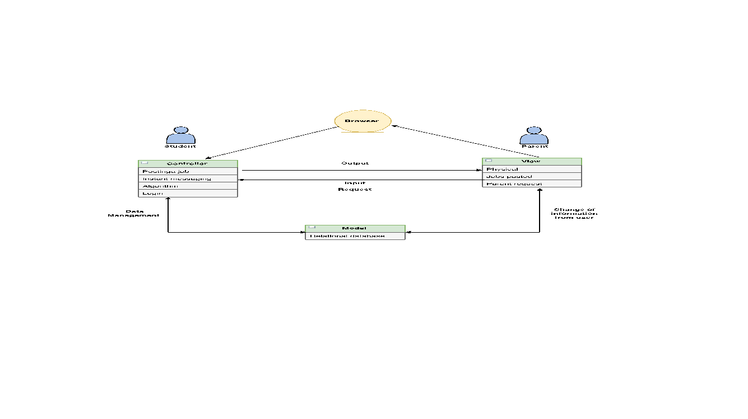

**Setting up the website interface**

The website will be built on 3 languages will include HTML/CSS and PHP. The HTML will be the structure of the document and the CSS will be the design part. The PHP element will be used throughout the web app as it will deliver information to the MySQL server. The login page will use PHP to store the information on cookies on the website and we will query the username and password to the MySQL database to match the user. The registration paper

**Register**

**User fills in details** 

**Login:** 

**User logs with a user** 

**And password**

The website will first have 2 pages:

* Main login page
* Main Registration page

The languages involved are:

* HTML
* CSS
* Bootstrap
* PHP
* MySQL

**Setting up the database**

MySQL will have at the start 4 distinct types of database in a relational database type. These database will be structured as:

|  |  |  |  |
| --- | --- | --- | --- |
| **Account** | **Job posting** |  |  |
| First name | Parent name |  |  |
| Last name | Applications count |  |  |
| Address | Student name |  |  |
| Skills | Skills required |  |  |
| Rating | Address |  |  |
| Messages | Money count |  |  |

**Transparency Layer**

https://www.google.co.uk/search?q=transparency+layer+for+white+text+website&source=lnms&tbm=isch&sa=X&ved=0ahUKEwia-b2v1_DYAhVHtRQKHcL2AbgQ_AUICigB&biw=1440&bih=826#imgdii=mf08UUSs9LgUuM:&imgrc=aT4uJ_bfFL-keM: **University student verification**

Shibboleth is an open source software used by over 350 universities in the UK. It allows student verification which we will use to allow students to login.

https://wiki.shibboleth.net/confluence/display/SHIB

**Webpages**:

https://www.tutorhunt.com/signup.asp